Functional Specification Interface
PRODUCTIONMETHOD

Document Management

Versioning
.
Version | Date | Description | Revised By
1.0 | 04/27/2020 | Initial Draft
1.0 | 5/8/2020 | a. Changed inboud file name and outbound file name to have timestamp instead of IDOC as per the requirement change  b. Changed Staging Error table data types to VARCHAR to load bad records  c. added new interface field – ProductionVersion
1.0 | 5/8/2020 | a. Added assumption regarding the length of “Key for Task List Group_MachineName” that will be received from SAP as ProductionMethod
1.0 | 5/14/2020 | a. updated assumption to have one BOM active for productionmethod at any given point of time  b. Added additional error handling scenarios

Approvals
Version | Approval Date | Approved By | Role Function
1.0

Table of Contents

1. Interface Tracking 5
1.1 Interface Classification 5
2. Interface Functionality Requirements 6
2.1 Process Flow / Data Flow 6
2.2 Assumptions 6
2.3 Out of scope 7
3. EXTRACT LOGIC IN SAP 8
3.1 Source / Target Data Mapping 8
3.2 Data Filters 8
3.3 Extraction Logic 8
3.4 Data Retention 8
3.5 SeeBurger integration details 8
4. Inbound to JDA Mapping 9
4.1 Input file specification 9
4.2 Source file to JDA Destination Data Mapping 9
4.3 Data Filters 10
4.4 Data Selection – Delta or Full Load 10
5. Inbound to JDA Staging 11
5.1 Interface Load Logic 11
5.2 JDA Staging Table Strcuture 11
6. JDA Staging to JDA Core 12
6.1 Interface Load Logic 12
6.2 JDA Core Table Structure 12
7. Data Validation and Interface Failure 13
7.1 Data Validation 13
7.1.1 Flat File – Data Format Issues 13
7.1.2 JDA Staging Custom Validations 13
7.1.3 JDA Core Integrity Errors 13
7.2 Interface Failure 14
7.3 JDA Error Table Structure 15
7.4 JDA Error Outbound File Specification 15
8. Error Communication 16
8.1 Error Detection and Communication 16
9. Data Retention in Staging 17
10. Dependencies 18
10.1 Conversion / Cutover / Other Project Tasks 18
11. Open items 19

Interface Tracking

Interface Classification

Interface Number | INT_005
Interface Name | PRODUCTIONMETHOD
Direction (with respect to R/3) | OUTBOUND from SAP
Interface Type | INBOUND to JDA
Interface  Frequency | Daily Details: This interface will be loaded daily
Type of Records Sent | TXT File
Volume  (per single execution) | Average Volume:  Peak Volume:

Interface Functionality Requirements
Production Method defines the procedure for manufacturing a SKU. There can be one or more production methods for a Bill Of Metrial (BOM) to produce the SKU. ProductionVersion information interfaced from TataConsumer’s SAP System is referenced as Production Method (PRODUCTIONMETHOD) in BlueYonder’s Supply Planning.

Each Production Method can have one or more Production Steps associated with it which will be defined in steps involved in the production process, can be either sequential or parallel.
Production Method, Production Step and Bill Of Material for a given SKU will be used by Blue Yonder’s Supply Planning to plan the production process based on the available capacity and raw material inventory..

2.1 Process Flow / Data Flow
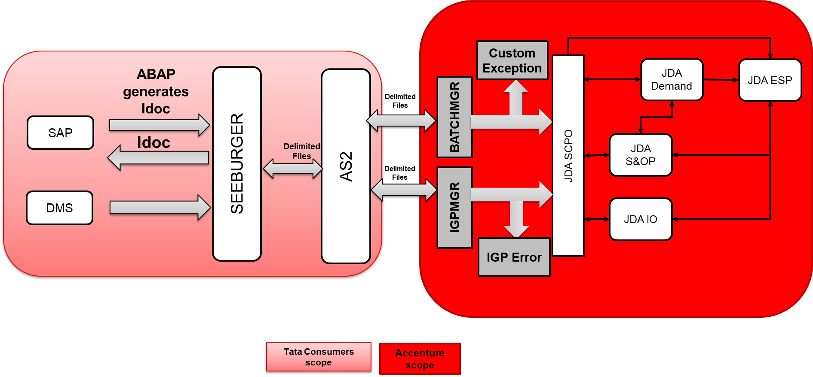

2.2 Assumptions
- Any changes to Production Method definition will be done in SAP and will then flow through this interface into JDA at the EOD. If there are multiple change pointers, SAP will consider all changes into one record to JDA at the EOD.
- SAP will concatenate “Key for Task List Group” with “Machine Name” and send KeyforTaskListGroup_MachineName” as PRODUCTIONMETHOD to JDA.
- The length of “Key for Task List Group_MachineName” which is sent as PRODUCTIONMETHOD from SAP to JDA will not exceed 50 Chars in length
- For a Finished Good at a Plant, Production Method defined is active with only one Bill Of Material (BOM) at any given point of time
- Errors would be send out daily if there are any to SAP through SEEBURGER.

2.3 Out of scope
- Any change in Production Method master as part of nomenclature in future to be handled separately and not considered at the time of preparing this design.

EXTRACT LOGIC IN SAP

3.1 Source / Target Data Mapping

ECC 6.0 / Seeburger

3.2 Data Filters

Sl.No | Plant
1 | INDP
2 | KELP
3 | NONP
4 | SAMP
5 | KOLP
6 | AURP
7 | BLRP
8 | DDMP
9 | HBDP
10 | PULP
11 | SONP
12 | KOLL
13 | GOLP

S. No | Material Type
1 | BLND
2 | PKTE

3.3 Extraction Logic
Assumptions
- Daily Full Load as mentioned against the interface list
- Scope of the Production Method is limited to data as shared in the interface file (13 Plants and 2 Material Types)
- Program will be executed in background, and variant will be saved for execution of the program
- Plants and Material Types can be added and removed from the list

Tables to be used for extracting the data
- MARA
- STPO
- MAST
- MARC
- MKAL
- PLPO
- CRHD
- MKAL_AEND
- MAPL
- CDHDR
Input Screen Selection
SL # | Field Description | Technical Details | Mandatory Field  YES/NO | Field Type
1 | Plant | MARC-WERKS | YES | Select-Option
2 | Material Type | MARA- MTART | YES | Select-Option

Output (Data to JDA)
- Field delimiter: “~” (tilde) character
- Text file
- There will be a header record with the following fields, separated by delimiter “~”
- Seeburger team to use ‘Interface Header Fields’ to create the header on the file.
- Below are the details regarding format of the file content.
- The text file will be concatenated with format YYYYMMDDHHMMSS

SL # | Field Description | Field Name | Data Tye | Format (If Applicable) | Table Mapping/Logic | JDA fiels Name  (output)
1 | Material Number | MATNR | VARCHAR(18,0) |  | MKAL _MATNR | ITEM
2 | Plant Code | WERKS | VARCHAR(4,0) |  | MKAL -WERKS | LOC
3 | Production Version | VERID | NUM(2,0) |  | MKAL - VERID | U_PRODCTIONVERSION
4 | Group Number | PLNNR_ ARBPL | NUM(8,0) |  | MKAL- PLNNR  CRHD- ARBPL | PRODUCTIONMETHOD
5 | Alternate BOM | STLAL | NUM(2,0) |  | MKAL- STLAL | BOMNUM
6 | Valid From | ADATU | DATE  DD.MM.YYYY | DD.MM.YYYY | MKAL-ADATU | EFF
7 | Valid To | BDATU | DATE  DD.MM.YYYY | DD.MM.YYYY | MKAL-BDATU | DISC
8 | Supply Family | PRDHA | CHAR (2,0) |  | MARA-PRDHA | SUPPLYFAMILY

Program: Z1PP004REP_JDA

Logic for Full Load
Step 1: Pass Material Type (MTART) from Input to table MARA, Deletion Flag at client level (LVORM) equal to space, X-Plant Status (MSTAE) is not equal to 1.
Step 2: Pass all Materials (MATNR) to MARC with Input Plants (WERKS), Deletion Flag (LVORM) is equal to space.
Step 3: Pass Material (MATNR) and Plants (WERKS) from Table MARC by keeping Material Type Information to MKAL
Store Material, Plant, Version, Valid From, Valid To, AltBOM, Group Number, Group Counter in internal Table 1 by linking Material Type and remove duplicate entries with same Material and Plant by keeping lowest VERID (space, 1, 2, 3…)
Step 4: Pass Material (MATNR), Plant (WERKS), Group Number (PLNNR) from MKAL Table to MAPL Table with Deletion Indicator (LOEKZ) is equal to space.
Pick Material (MATNR), Plant (WERKS), Group Number (PLNNR), Task List Type (PLNTY) and Group Counter (PLNAL)
Step 5: Pass Task List Type (PLNTY), Group Number (PLNNR), Group Counter (PLNAL) to FM CARO_ROUTING_READ
With Oper./Act. (VORNR) Not equal to 0010, Base Quantity (BMSCH) as 1000
Collect Unique Collect Unique Group Number (PLNNR) and Object Id’s (ARBID)

PKTE Data (i.e Task List Type N) will be OPR_TAB
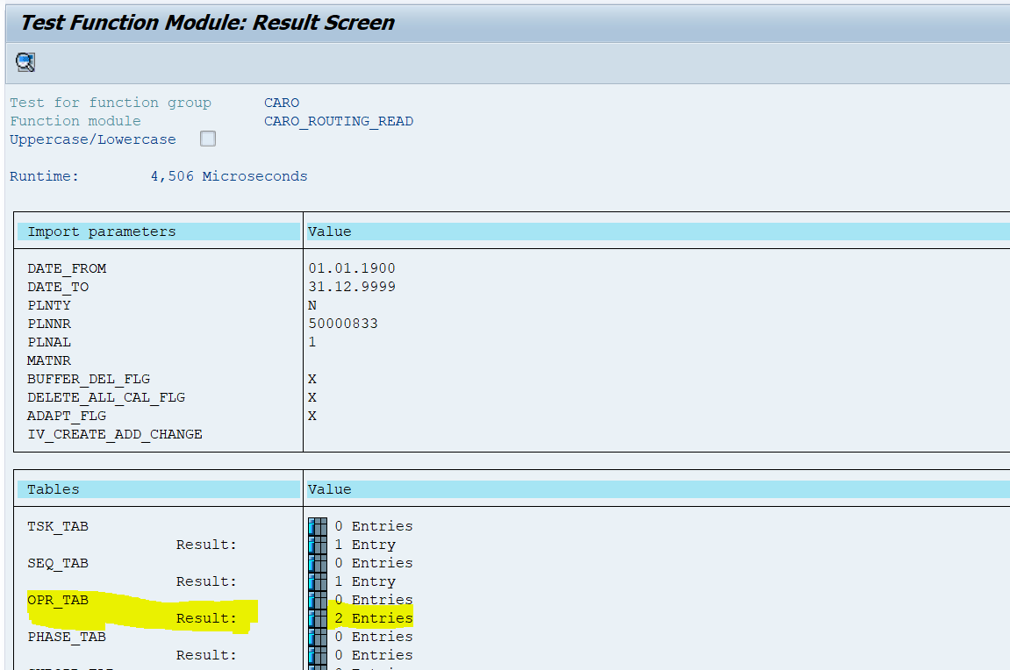

Blend Data ((i.e., Task List Type 2) will be PHASE_TAB
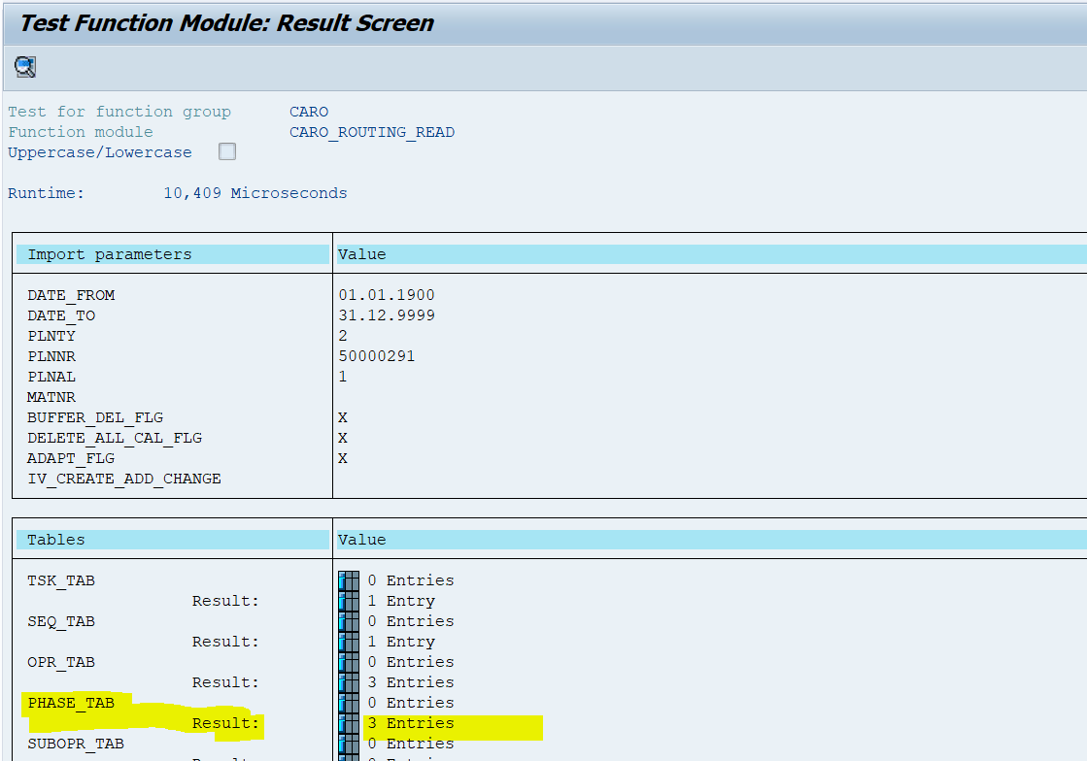

Step 6: Pass Object id’s(ARBID) from CARO_ROUTING_READ to table CRHD_Object id (OBJID) to get work Center.
Step 7: Now Map Group Number with Work Center Like 50000833_BN31 and display in report from MKAL, CARO_ROUTING_READ and CRHD.
If we have multiple entries for one group Number then loop complete records as like below.
Pass ITEM to AUSP and get U_SUPPLYFAMILY
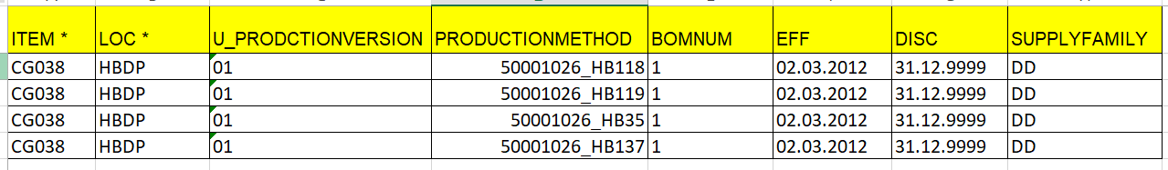

Validations:
Production Version and BOM Numner to maintained as 01 and if any other maitnatined then that will go into error.
Group Number(Production Method) is mandatory, if any blank maintained in Production Version then that will go into error.

Exclusions (Not in Scope)
Other Than Material Types PKTE and BLND are not part of scope.
Sample Output Data Format & Integration Master Document

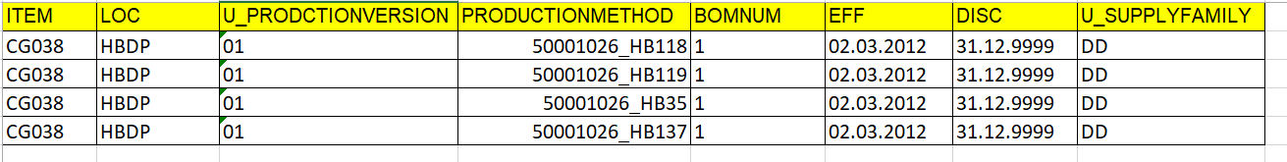

Execution Frequency and Timings
Daily Full Load
Frequency: Daily Once
Execution Timing: To be confirmed by JDA
Data Transfer and Error Handling
The final output from SAP interface will be stored to SAP AL11 folder JDA_IBP_Outbound, from where the files will be picked up by SeeBurger and processed to JDA-AS2 folders.
SeeBurger will attach the file name (With date and timestamp) in the output file before transferring the data to JDA and this filename will be used as reference while error logging.
During Errors, the error files will be received by SeeBurger in the below format and send to SAP for correction.
- Filename
- Complete error record information (All the field values)
- Error Description
Once the error is corrected, SAP will be sending the corrected records (ONLY) to JDA. When the files are picked up from AL11 folders and while receiving error files, SAP will be alerted by SeeBurger using E-Mails.
The data files will be archived in SeeBurger Server for a period of 3 to 6 months depending on the volume and GIS-SAP team will have access to the processed file location in SeeBurger for error handling and future reference.

Data Retention

Data will be placed in seeburger for 3 month
Output data will not be stored in SAP ECC.

SeeBurger integration details

Inbound to JDA Mapping
With this interface, Production Method data which is available as flat files in AS2 folder from SAP will be first loaded on to JDA Staging Schema and then the data will be moved from JDA Staging Schema (IGPMGR) to JDA Destination Schema (SCPOMGR).

Input file specification

Production Method data from SAP to JDA will be available as flat files. Below are details regarding naming and format of the inbound file.
Inbound file will be received as JDA_PRODMETHOD_<TIMESTAMP>.txt. TIMESTAMP represent the time when the data is extracted in SAP System.

Below are the details regarding format of the file content.
JDA_PRODMETHOD_<TIMESTAMP>.txt
- Field delimiter: “~” (tilde) character
- Text file
- There will be a header record with the following fields, separated by delimiter “~”. Data records has field information as per the header record
- Seeburger team to use ‘Interface Header Fields’ to create the header on the file.
Interface Header Fields | Description
ITEM | Material Number
LOC | Plant Code
U_PRODCTIONVERSION | Production Version
PRODUCTIONMETHOD | Key for Task List Group_MachineName
BOMNUM | Alternative BOM Number
EFF | Valid From date
DISC | Valid To Date
U_SUPPLYFAMILY | Supply Family

